# Azure Managing VMs

# 

## **Tutorial**

In this tutorial, we will be changing a VM size using a custom image.

1. **Create a new VM, of size Standard_B1s (*1 CPU, 4GB SSD*)**:

**$ az group create -n azTut -l uksouth**

**$ az vm create -g azTut -n tutVm -l uksouth --image UbuntuLTS --size Standard_B1s --generate-ssh-keys**

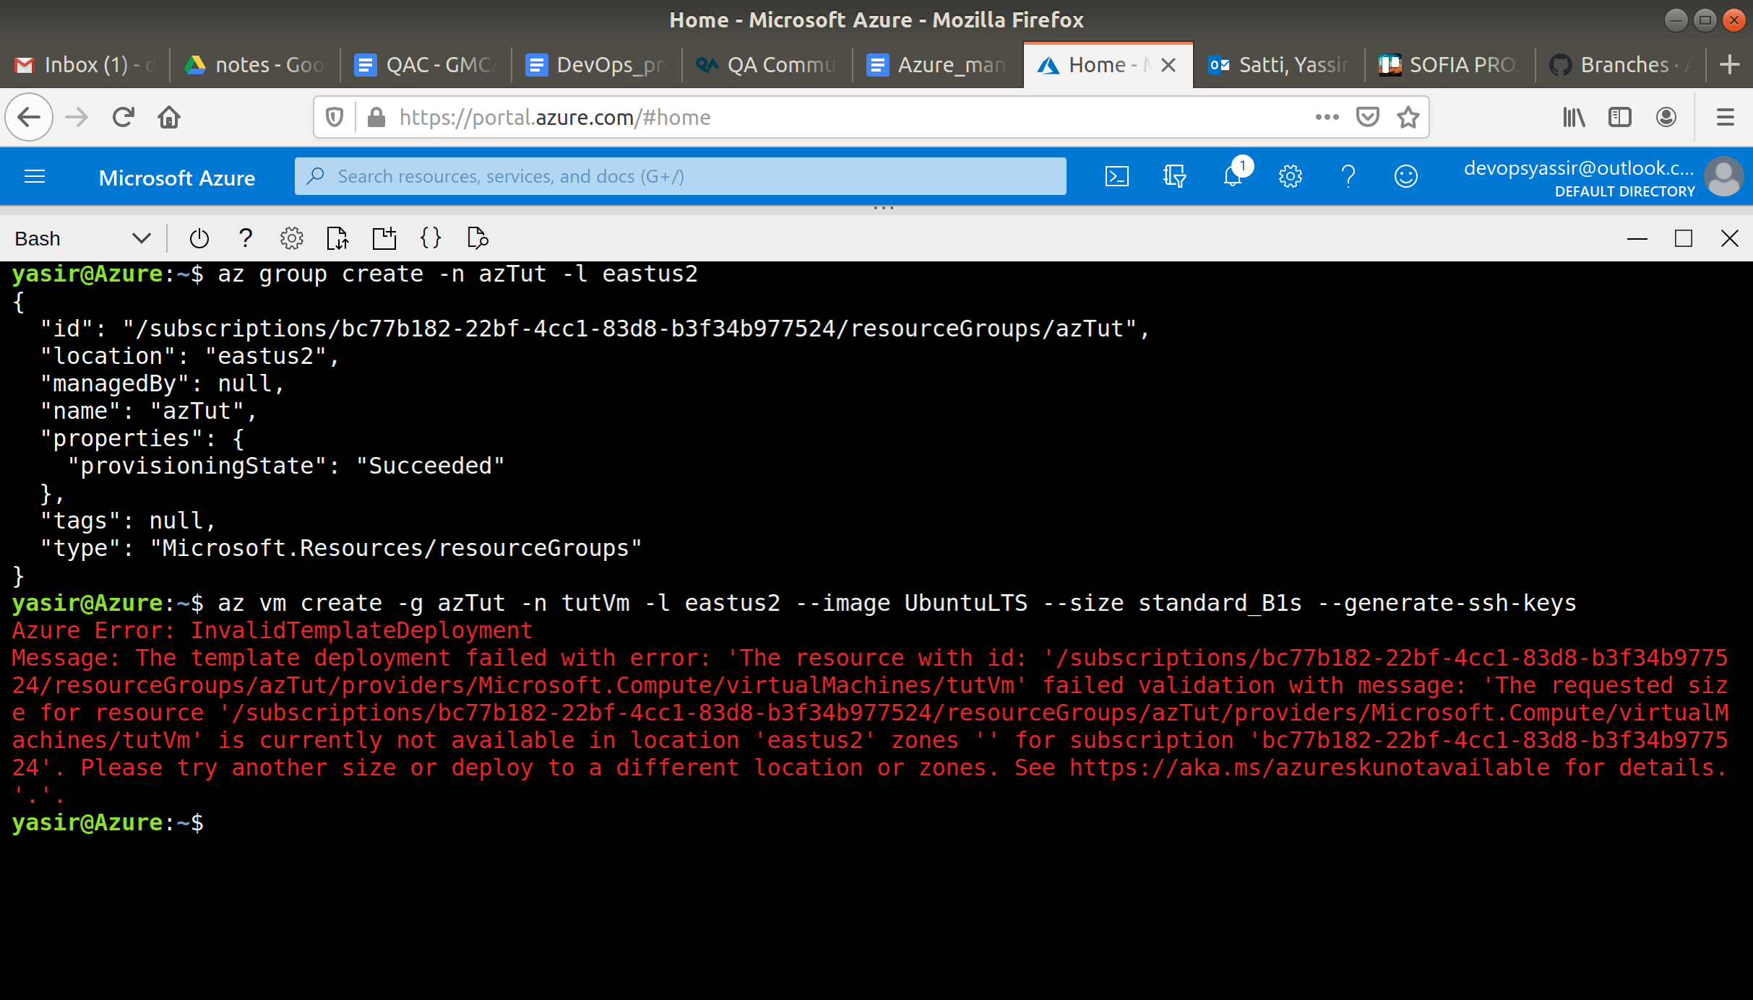

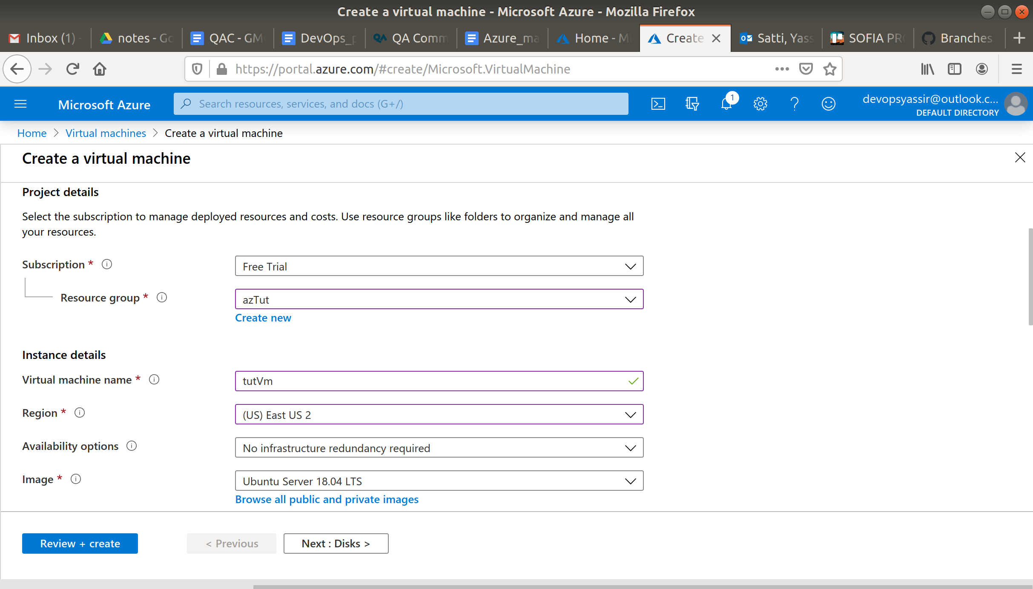

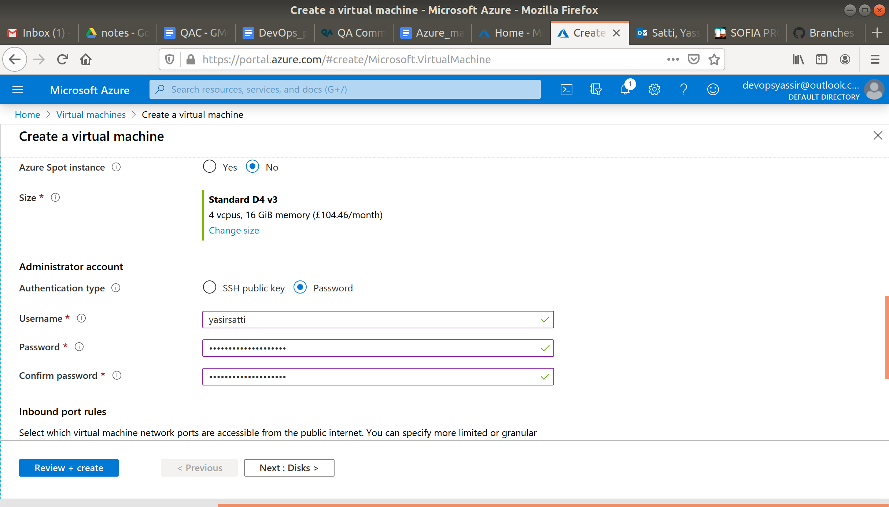

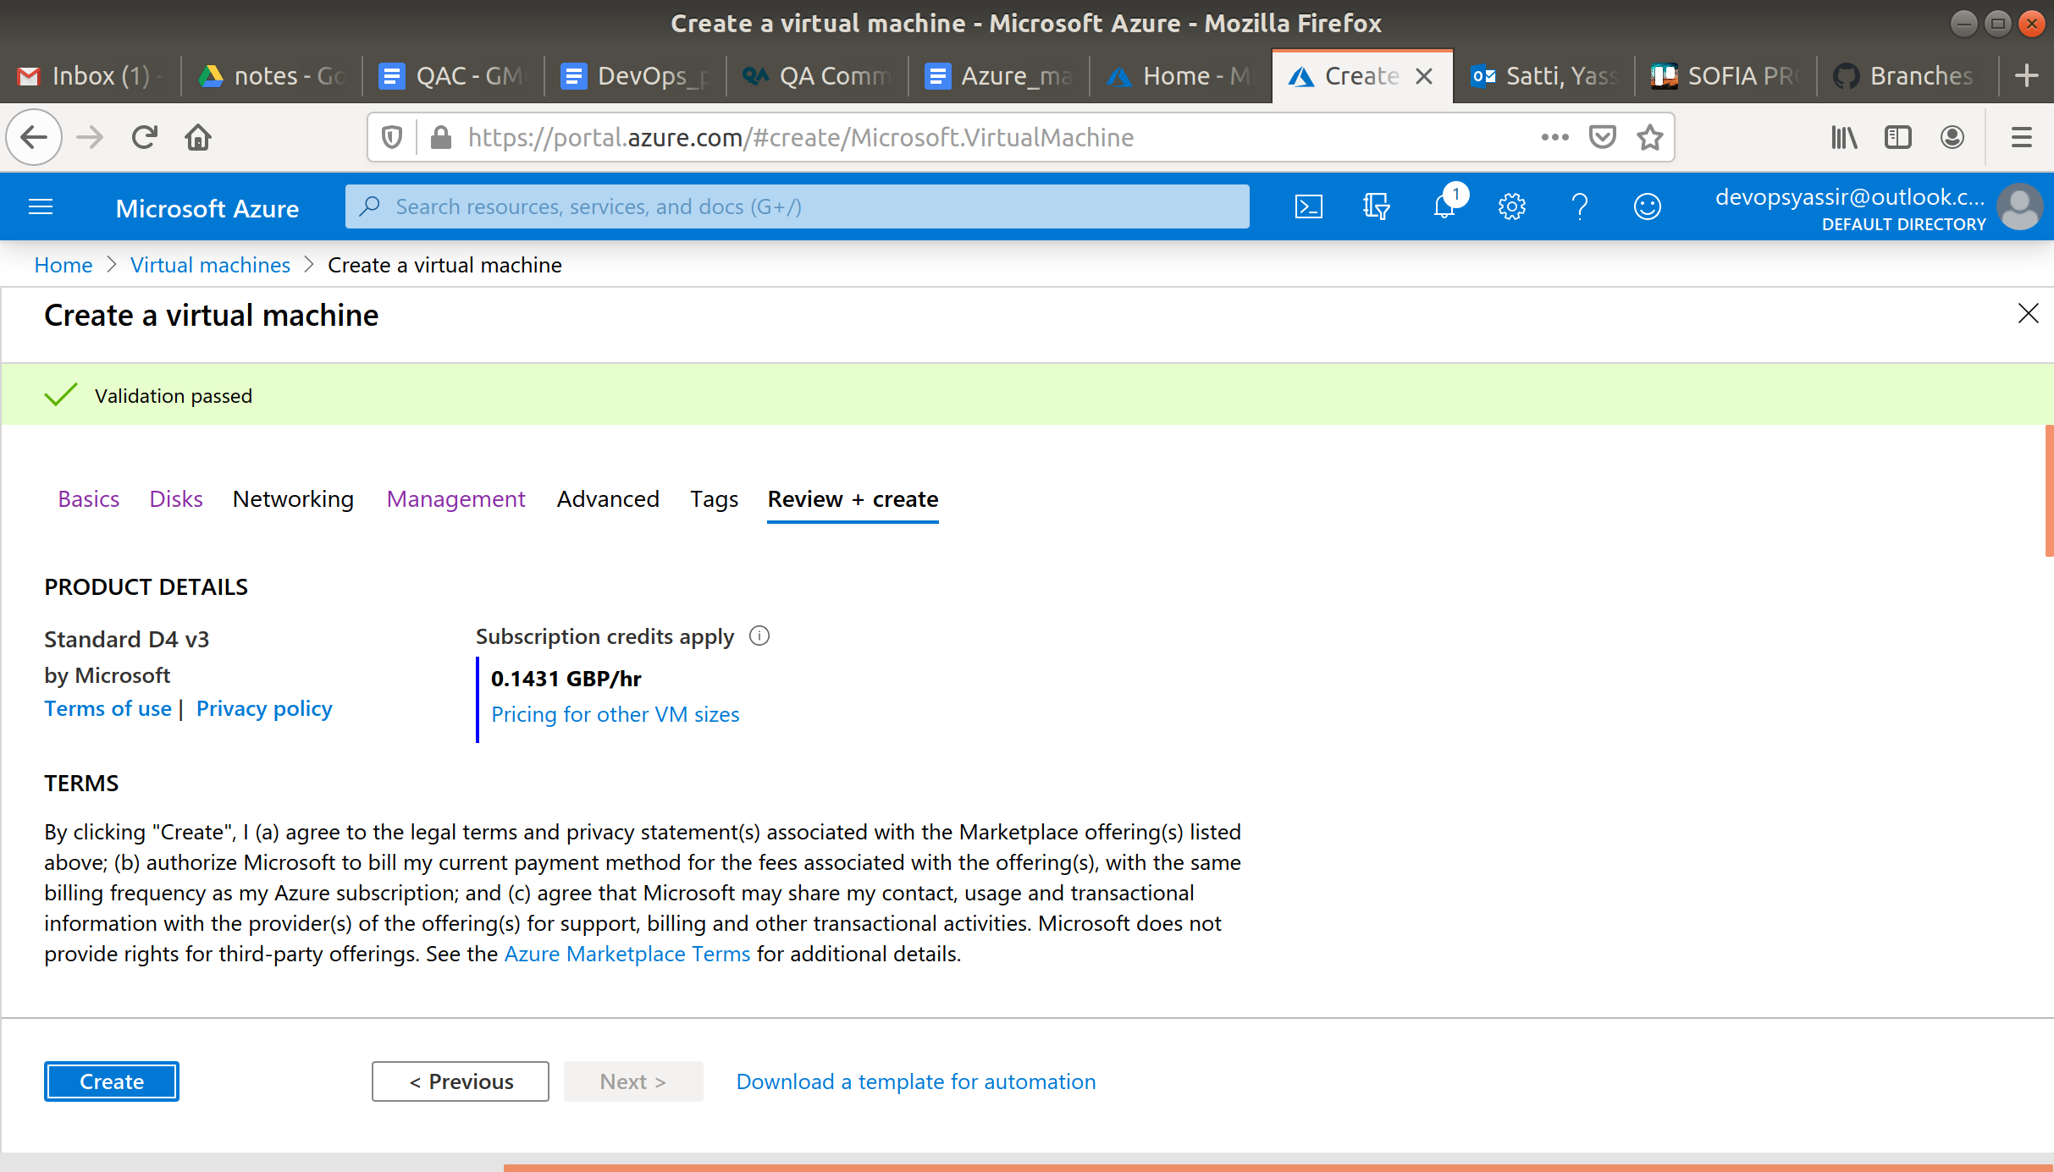

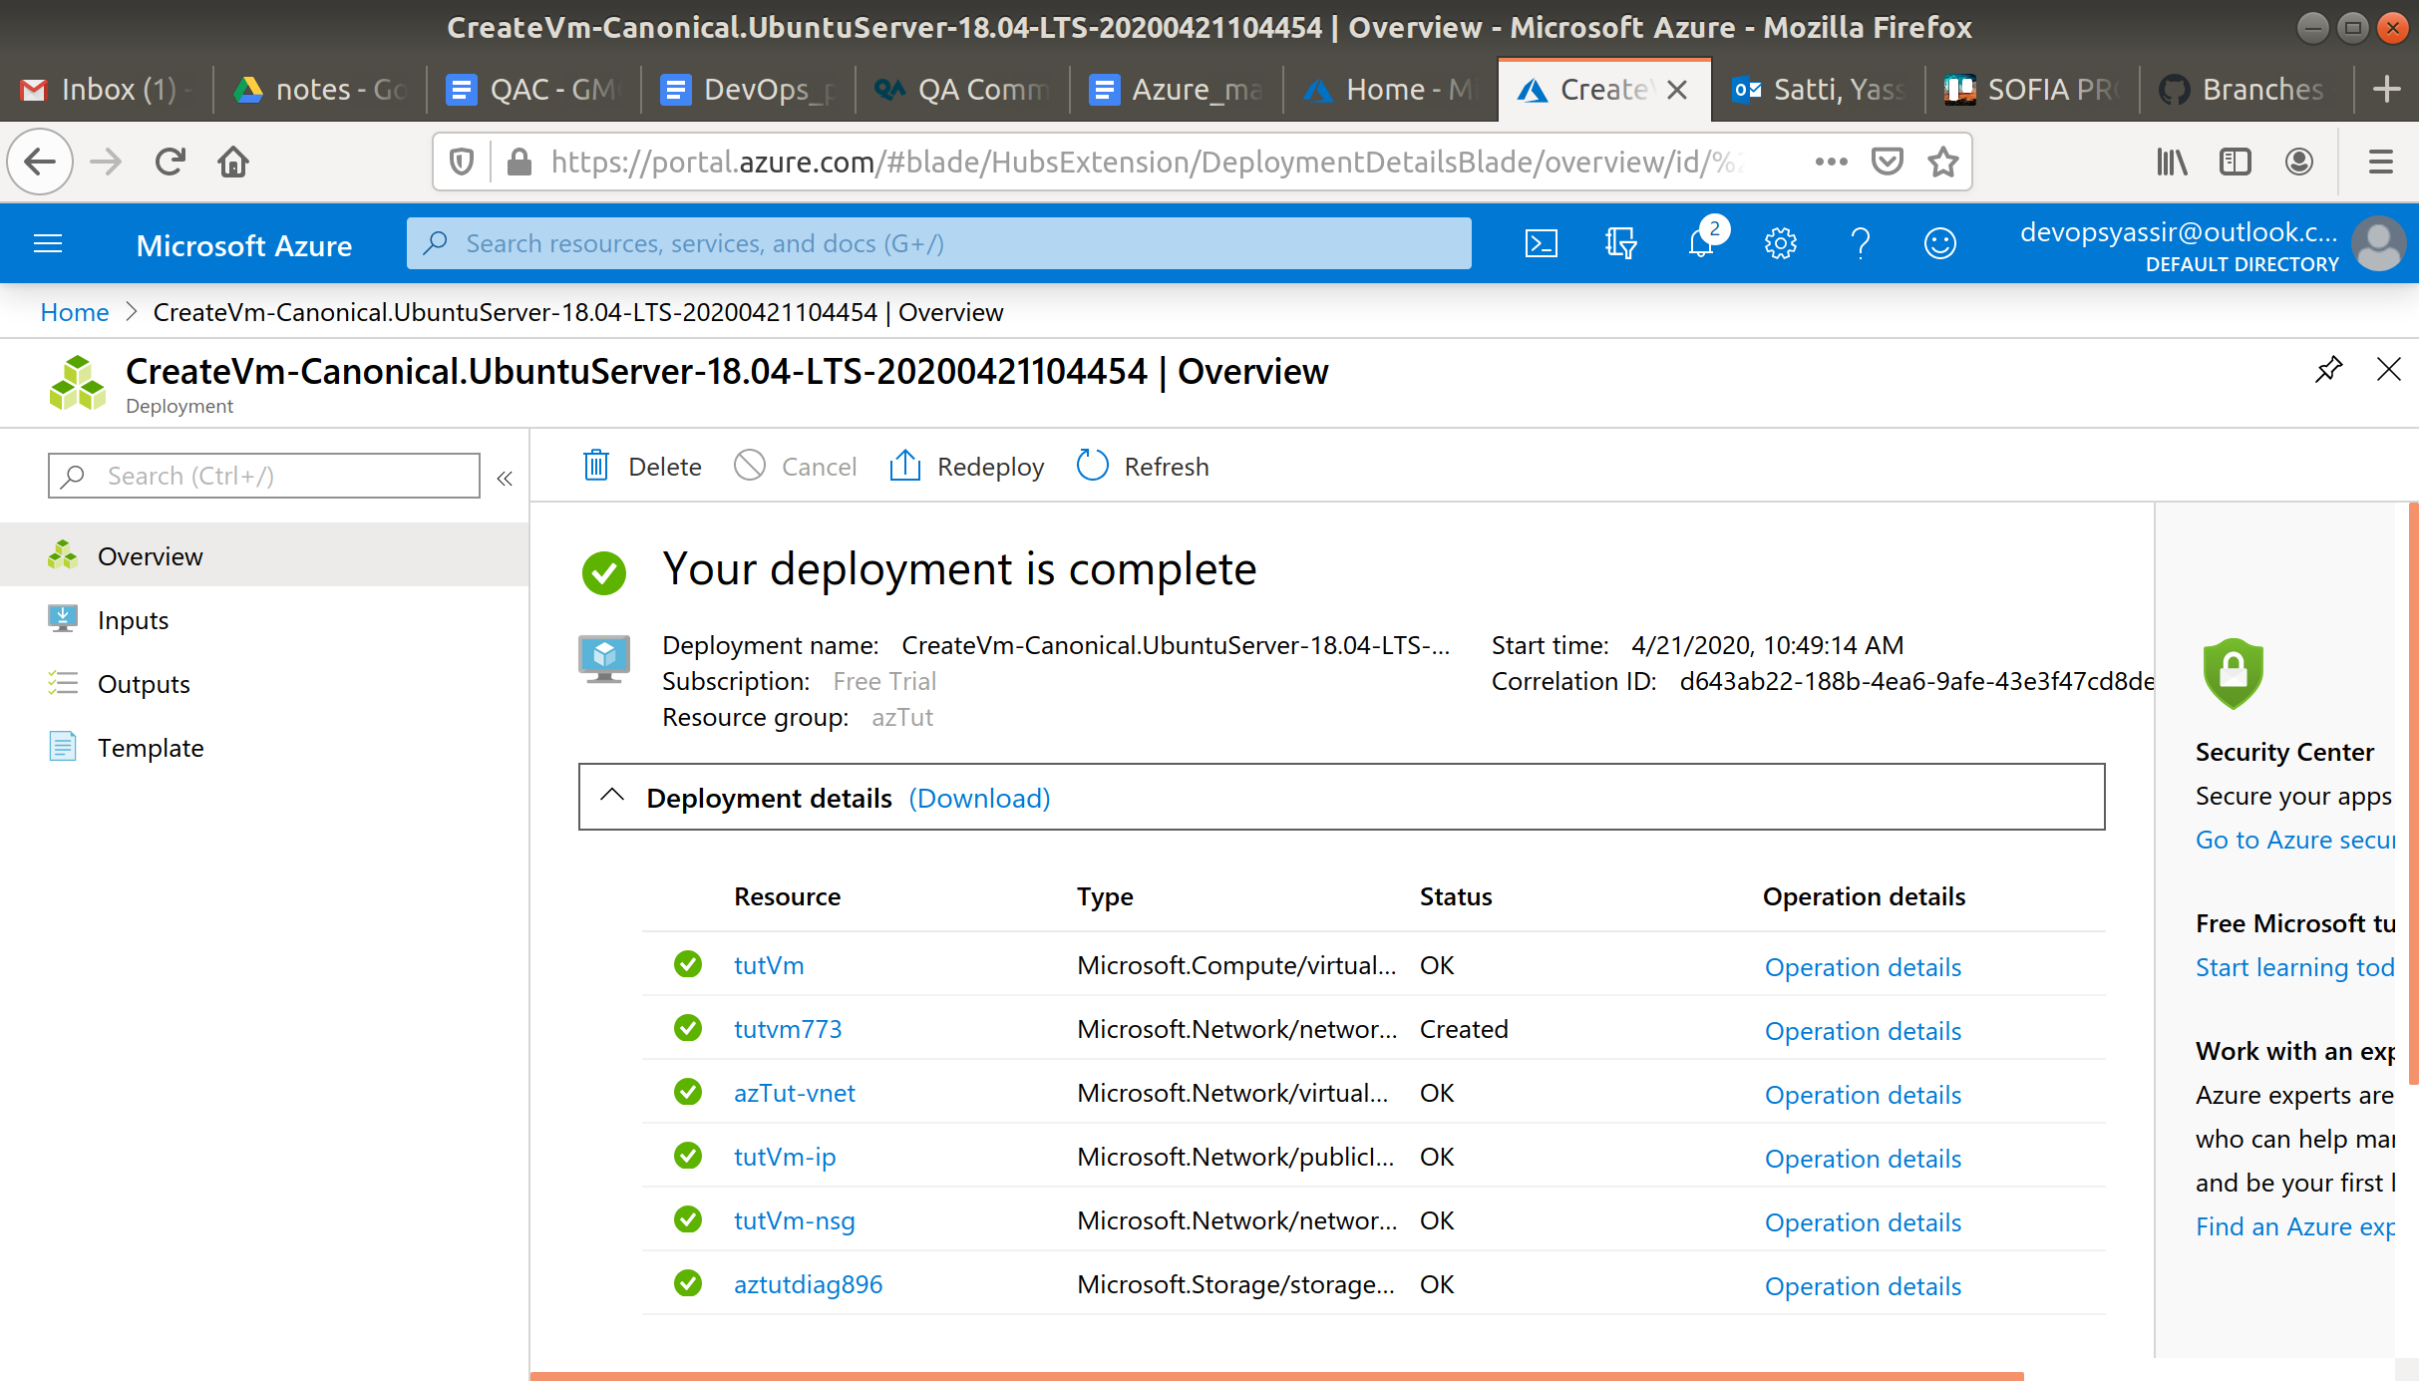

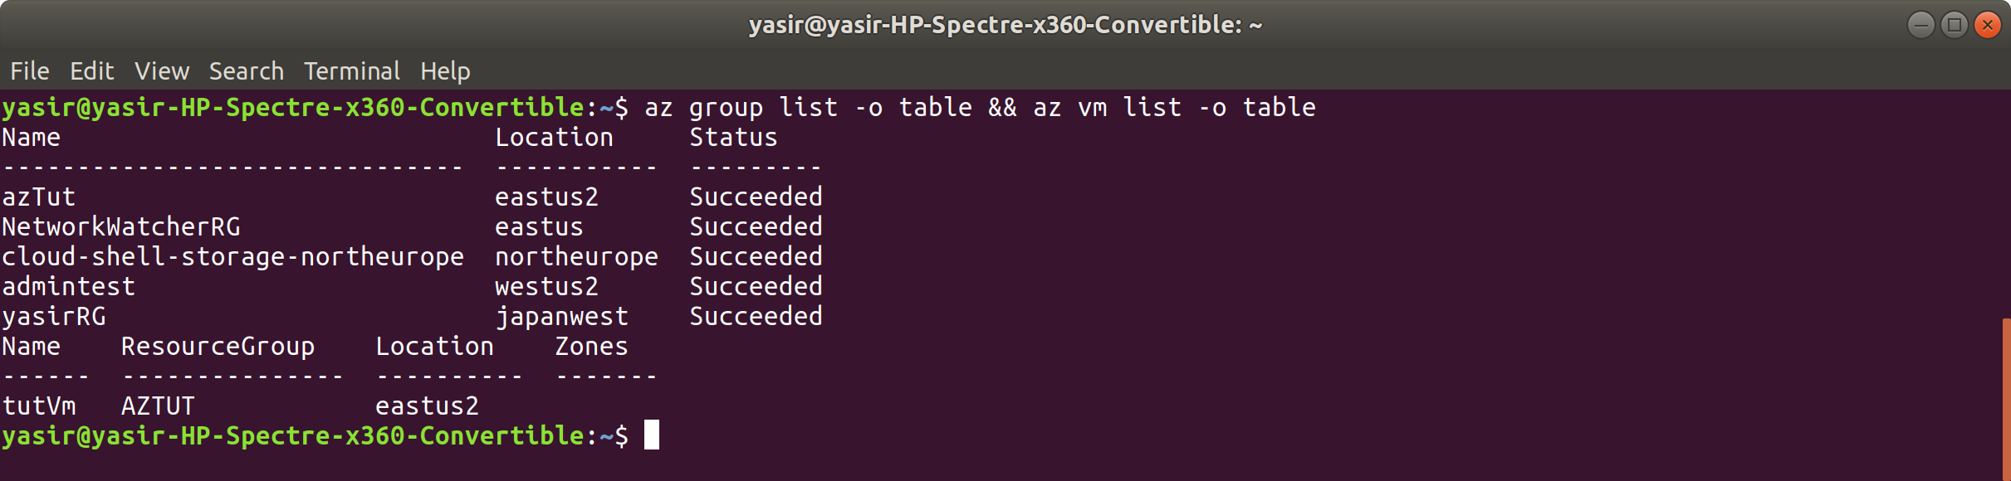

1. **Obtain the public IP of the VM**:

**az vm show -g azTut -n tutVm -d --query [publicIps] -o table**

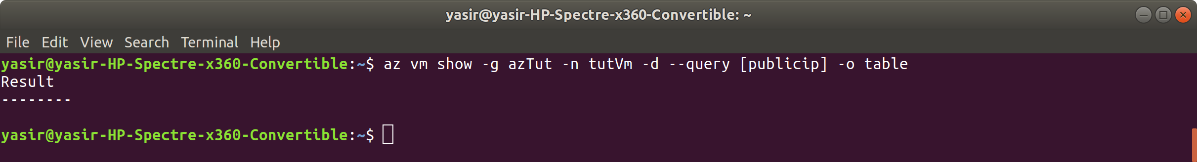

got the public ip from the Azure portal

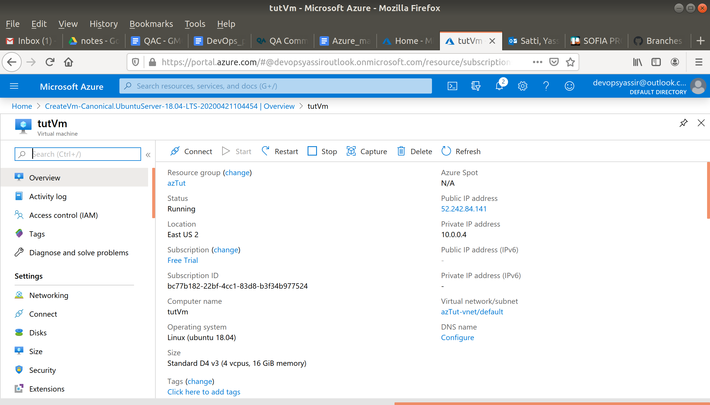

1. **SSH onto the VM and install Docker**:

**$ ssh <publicip>**

Replace <publicip> with the IP you obtained from step 2.

**$ curl https://get.docker.com | sudo bash**

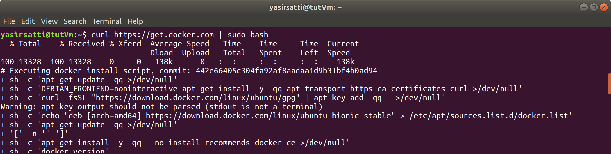

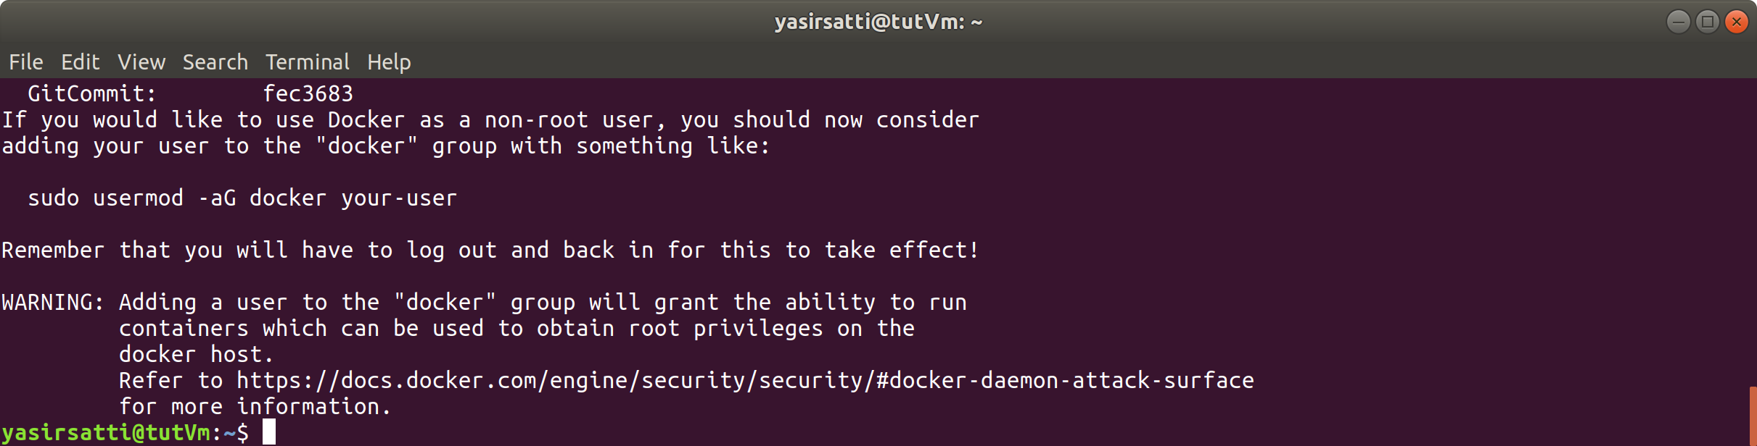

1. **Check Docker is installed**:

**$ sudo docker version**

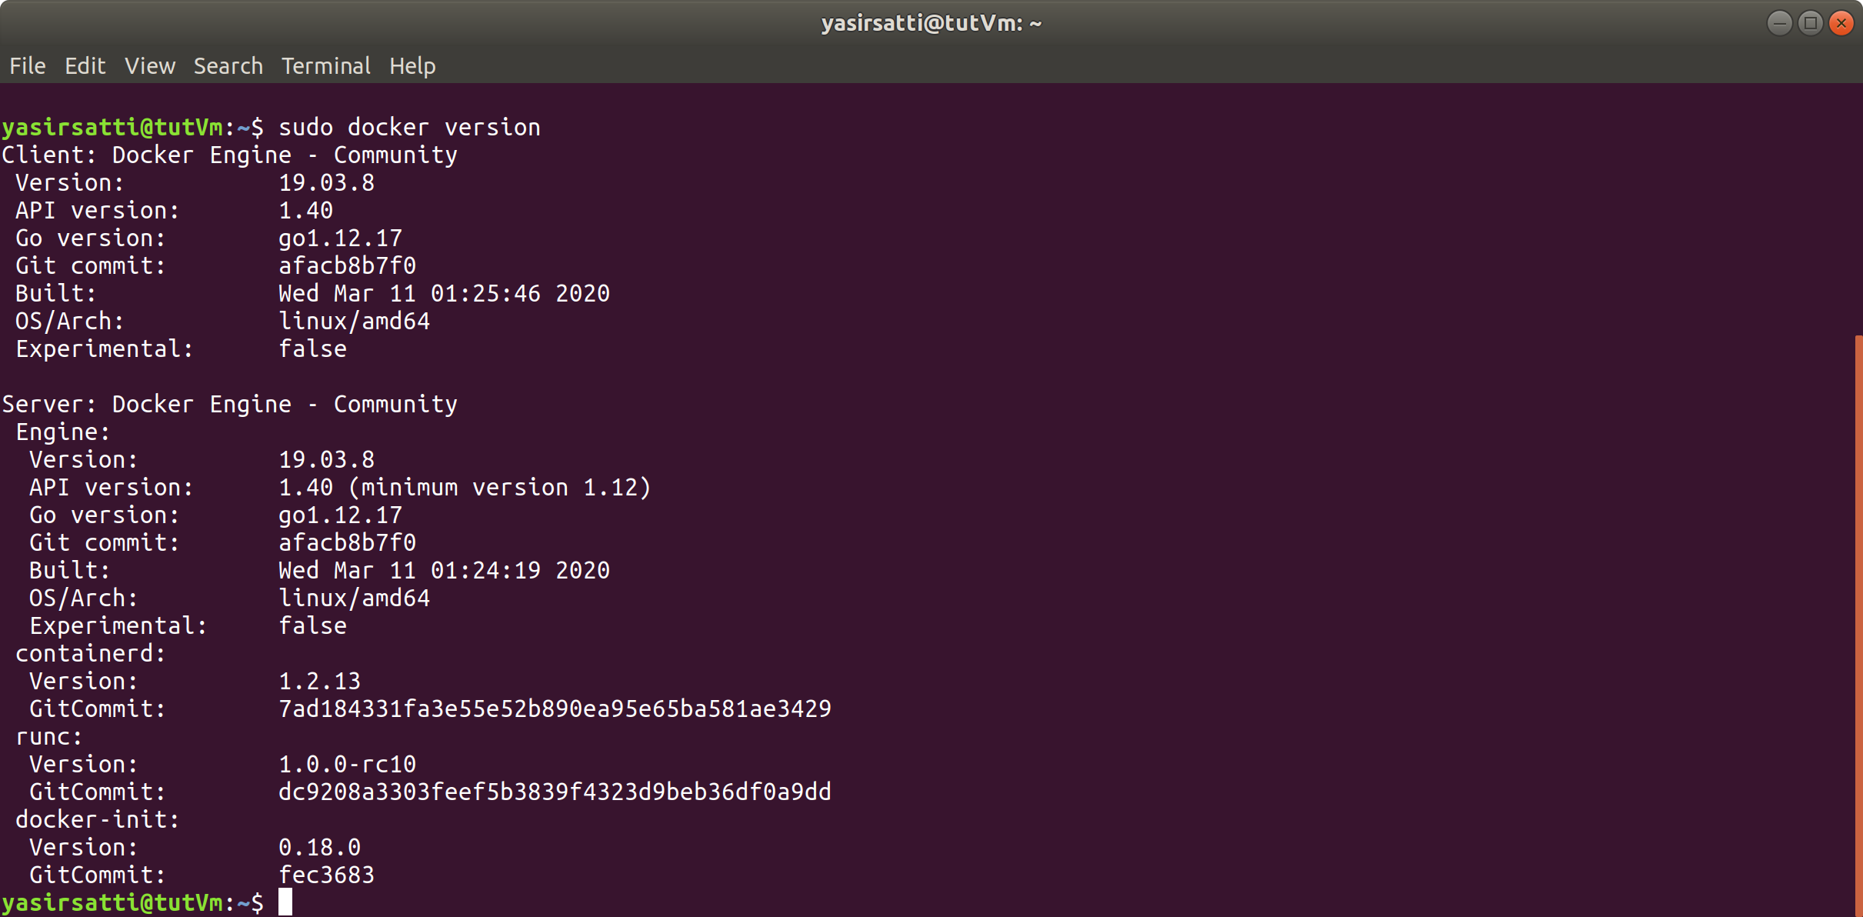

1. **Deprovision the VM**:

**$ sudo waagent -deprovision+user -force**

**$ exit**

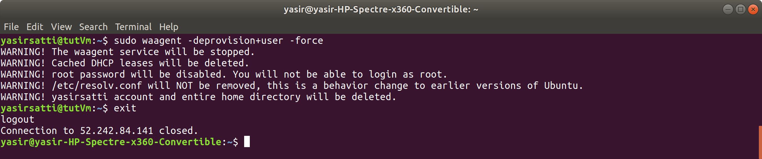

Deprovisioning generalises the VM by removing machine-specific information. This generalisation makes it possible to deploy many VMs from a single image.

1. **Deallocate the VM**:

**$ az vm deallocate -g azTut -n tutVm**

**( what it means to deallocate Azure Vms** [**https://support.hostway.com/hc/en-us/articles/360001059850-Deallocate-Azure-Virtual-Machines**](https://support.hostway.com/hc/en-us/articles/360001059850-Deallocate-Azure-Virtual-Machines) **)**

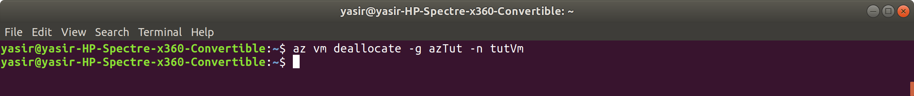

1. **Mark the VM as Generalised**:

**$ az vm generalize -g azTut -n tutVm**

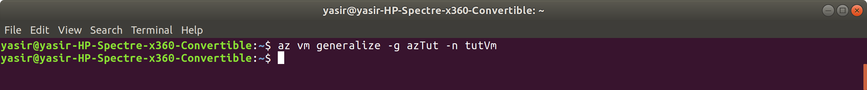

1. **Create the Image**:

**$ az image create -g azTut -n tutImage --source tutVm**

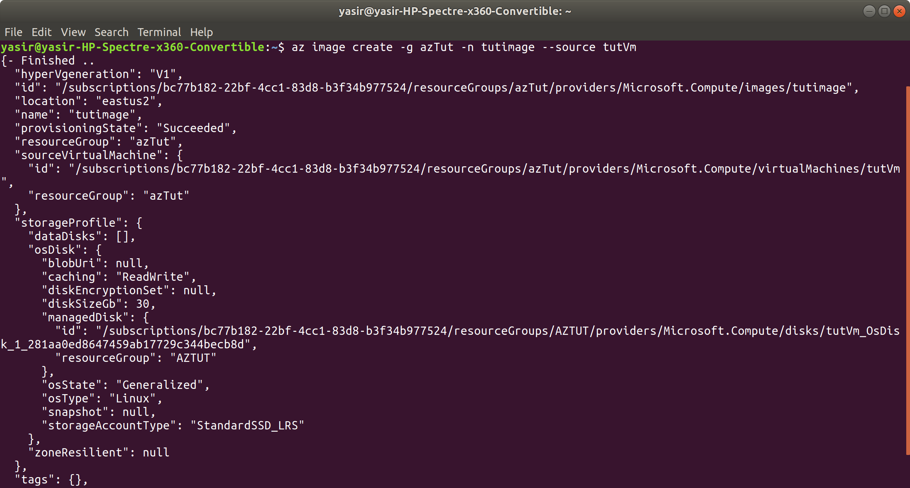

1. **List your images**:

**az image list -g azTut -o table**

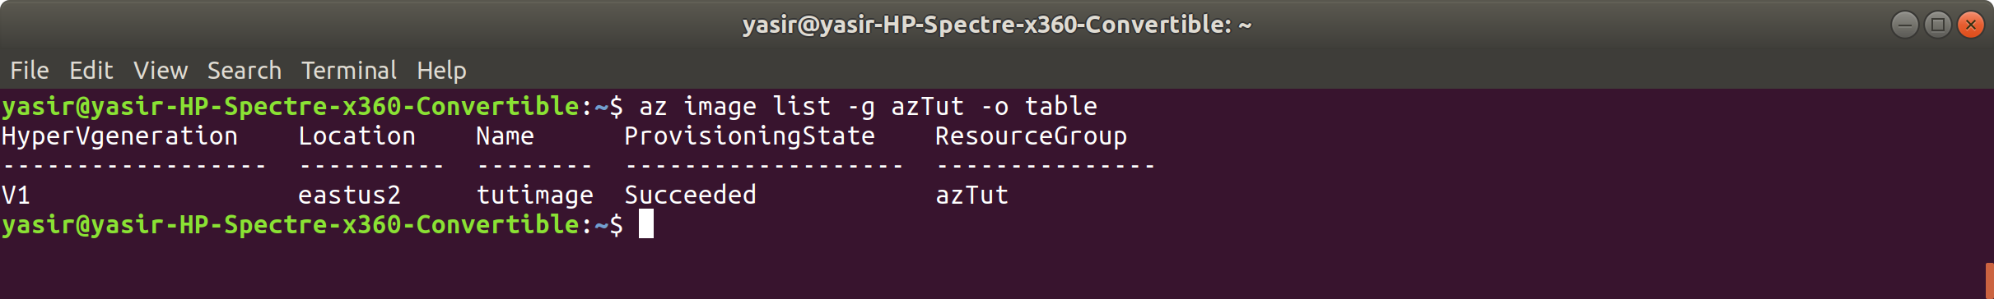

1. **Create a larger VM from the Custom Image, of size Standard_D4s_v3 (*4 CPU, 16GB SSD*)**:

**$ az vm create -g azTut -n tutVmNew -l uksouth --image tutImage --size Standard_D4s_v3 --generate-ssh-keys**

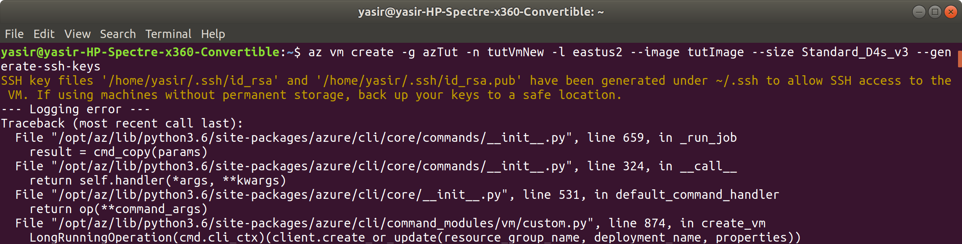

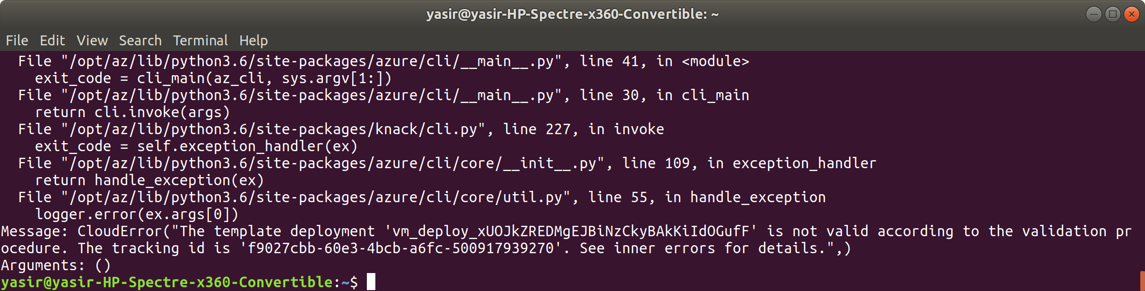

1. **Check Docker is still installed on the new machine**:

az vm show -g azTut -n tutVmNew -d --query [publicIps] -o table

ssh <publicip>

sudo docker version

exit

1. **Clean Up**:

az group delete -n azTut -y --no-wait

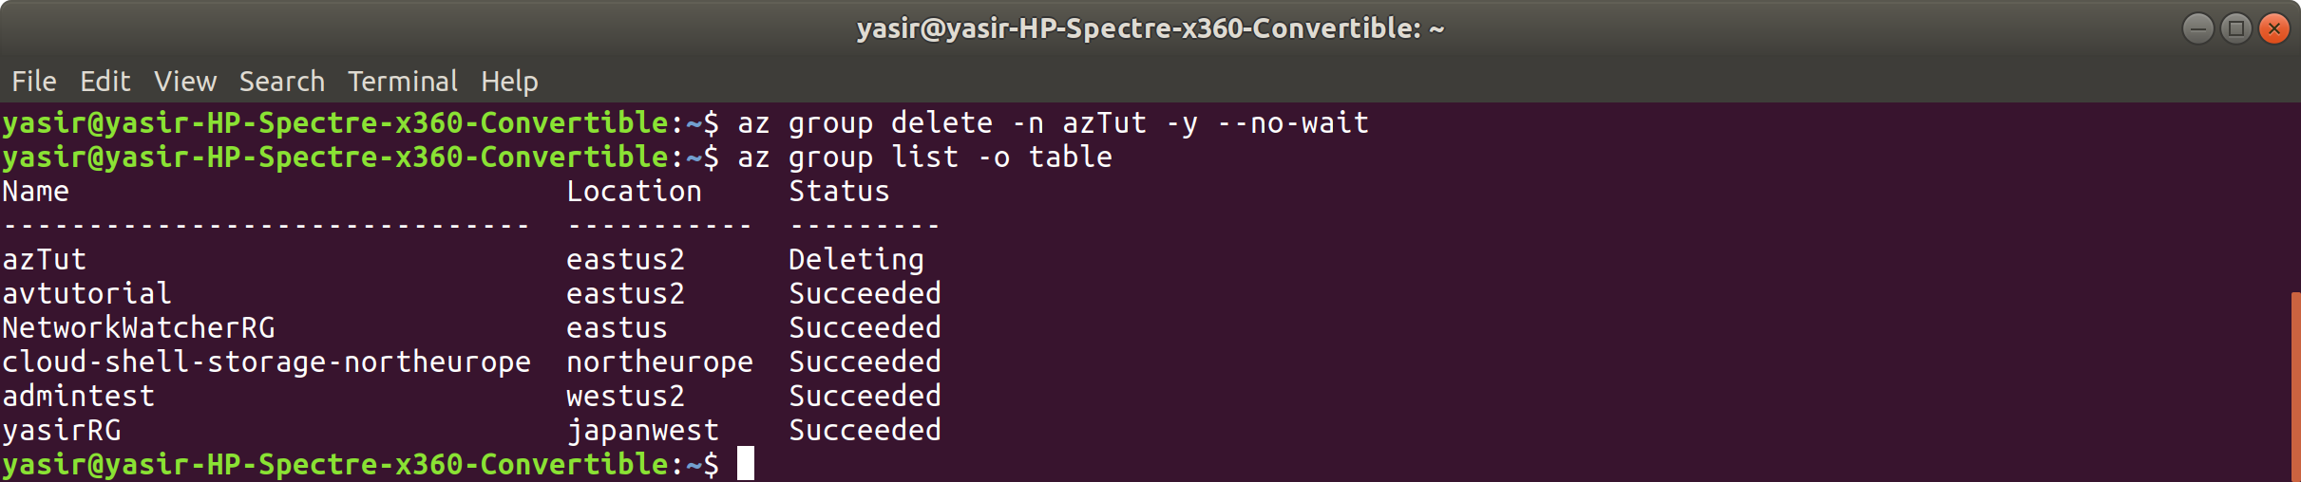

**We've now increased our VM size, using a custom image!**